**33.PERSONAL LOAN MANAGEMENT SYSTEM USE CASE DIAGRAM:**

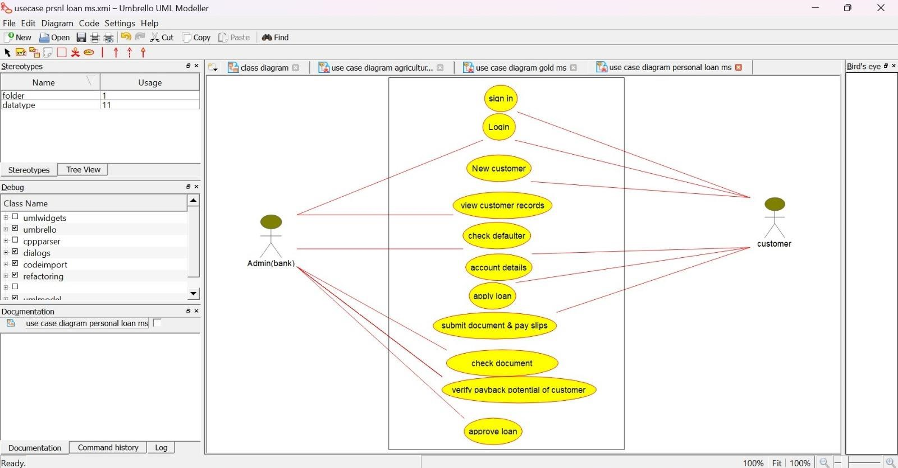

**CLASS DIAGRAM:** 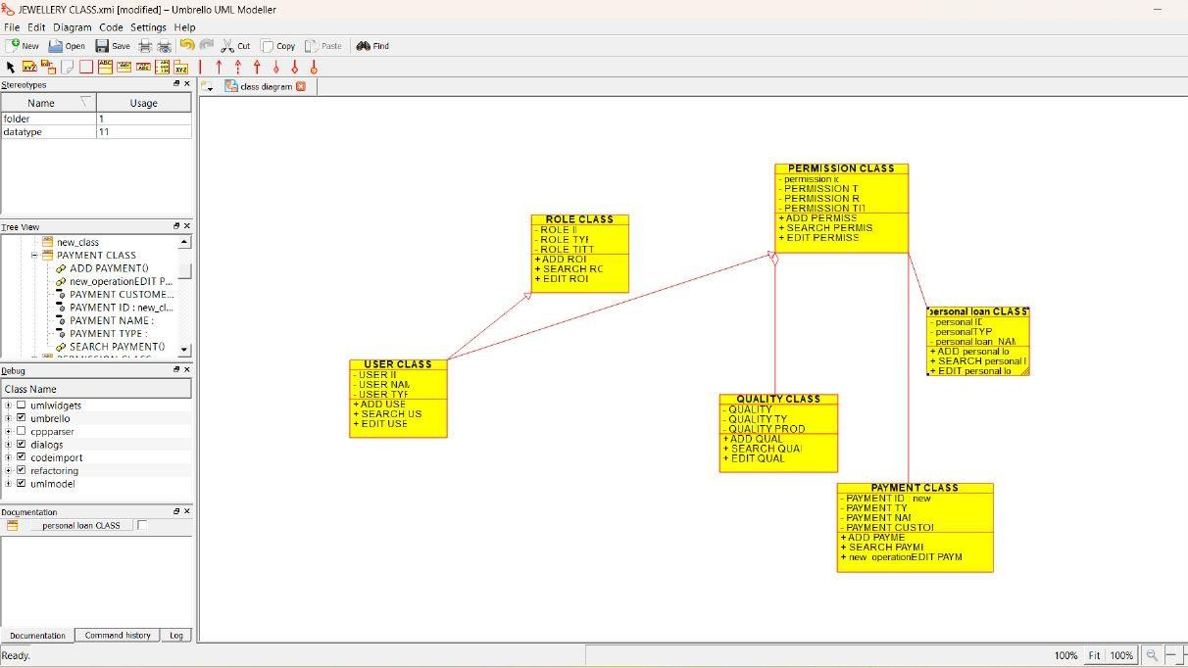

**SEQUENCE DIAGRAM:**

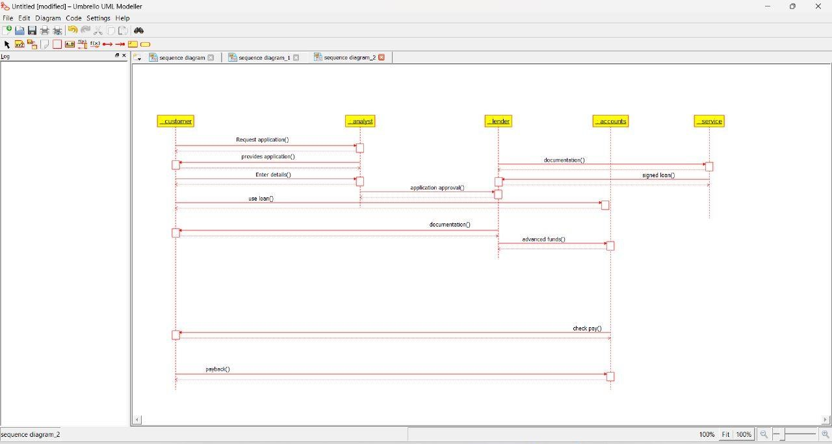

**34.HOME LOAN MANAGEMENT SYSTEM USE CASE DIAGRAM:**

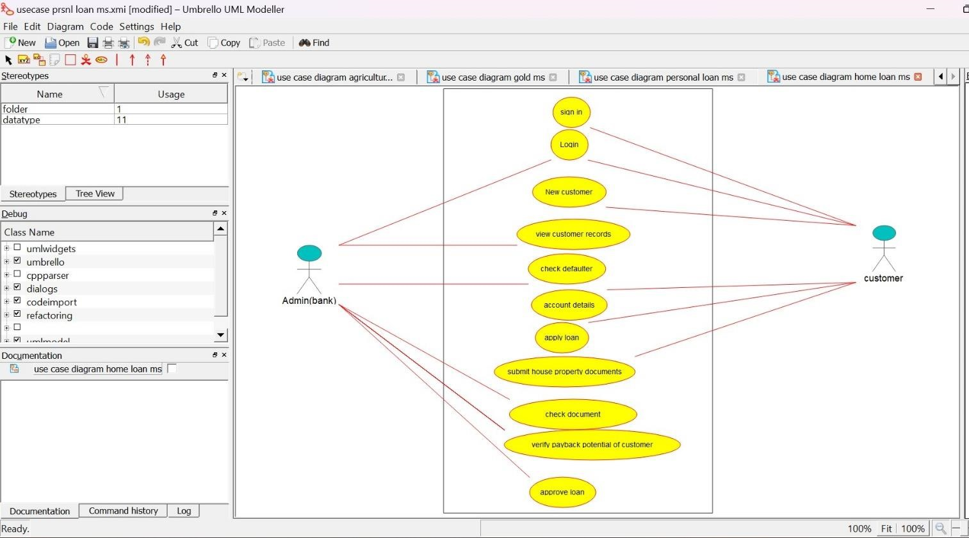

**CLASS DIAGRAM:**

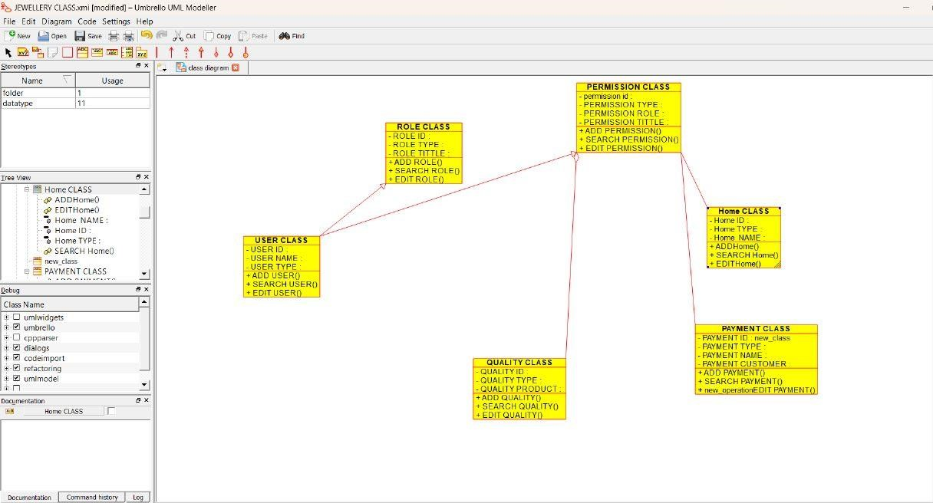

**ACTIVITY DIAGRAM:**

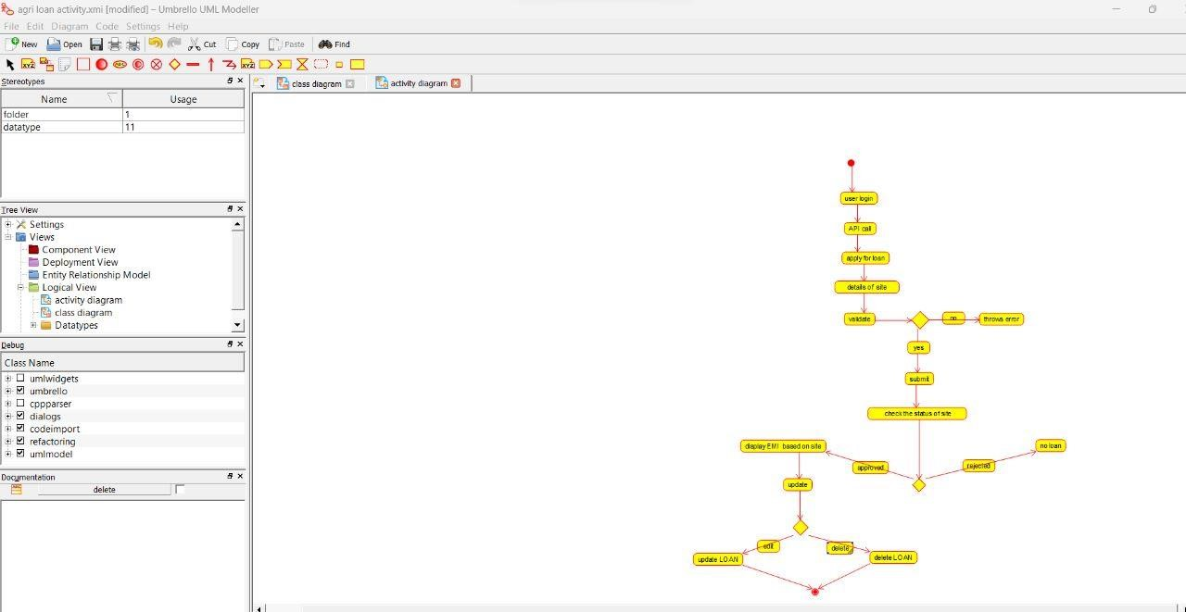

**35.LAND REGISTRATION SYSTEM**

**USE CASE DIAGRAM:**

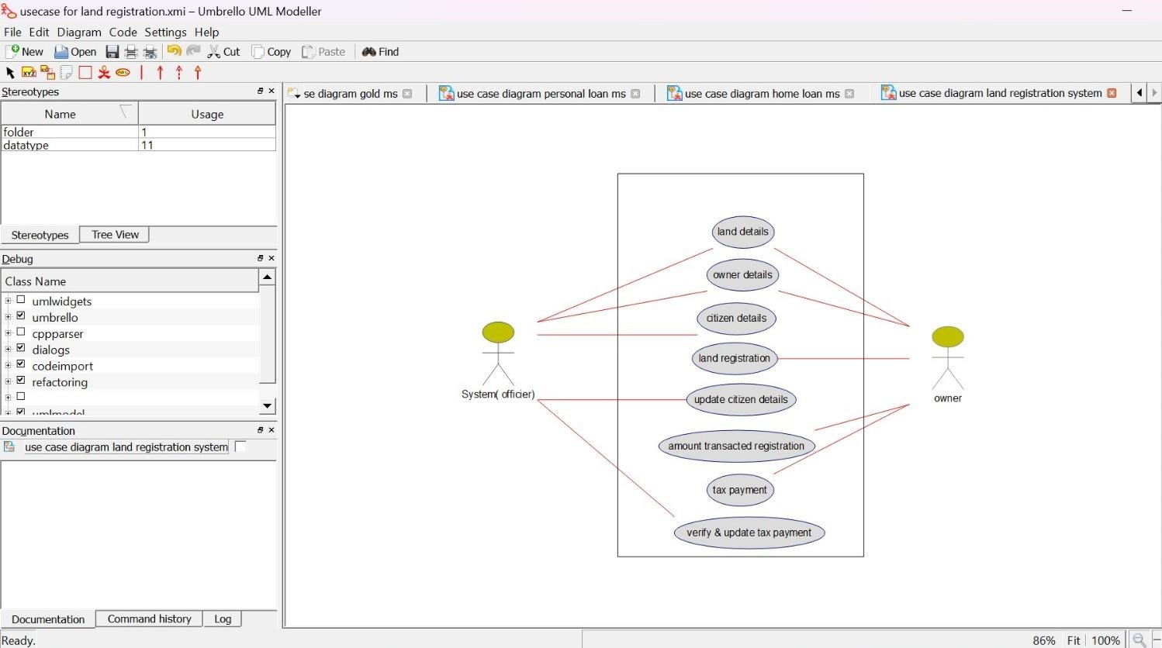

**CLASS DIAGRAM:**

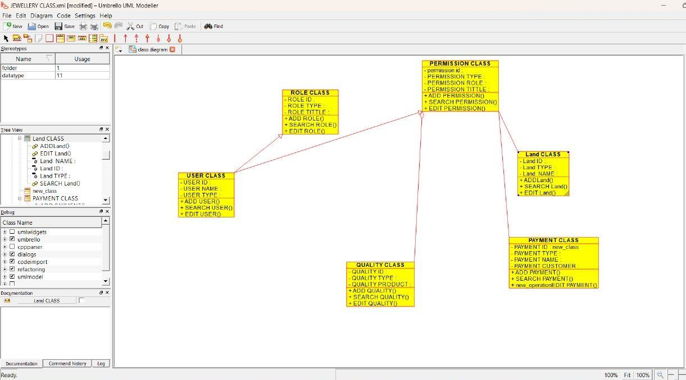

**ACTIVITY DIAGRAM:**

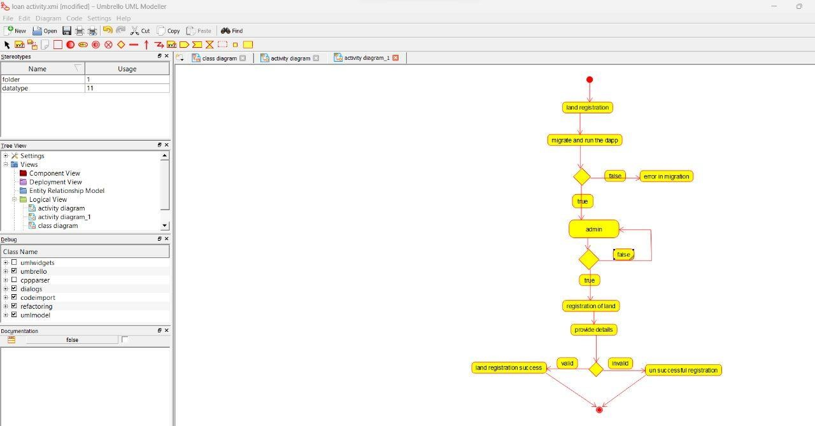

**36.VEHICLE BOOKING SYSTEM USE CASE DIAGRAM:**

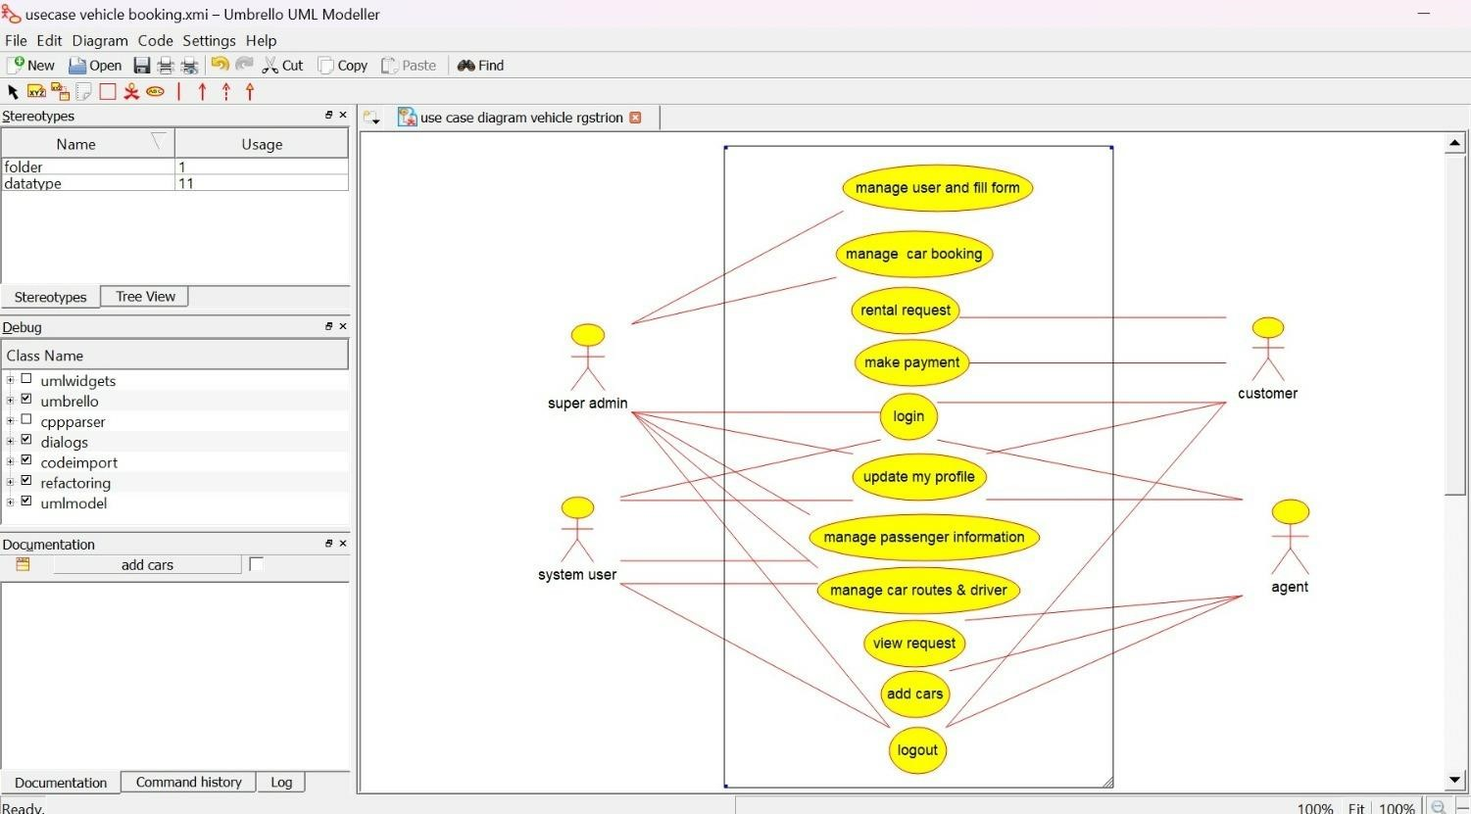

**CLASS DIAGRAM:**

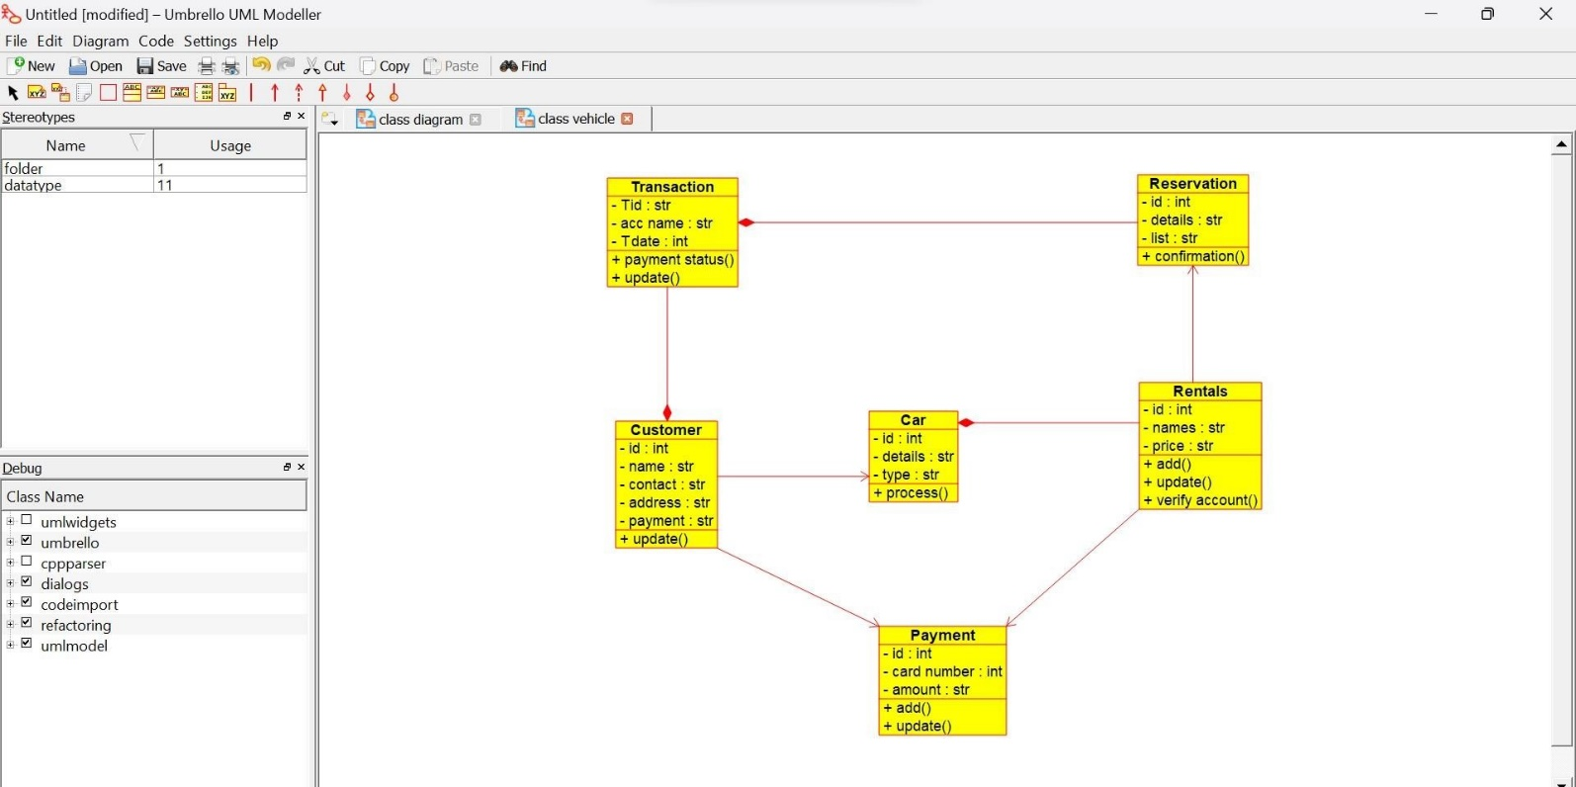

**SEQUENCE DIAGRAM:**

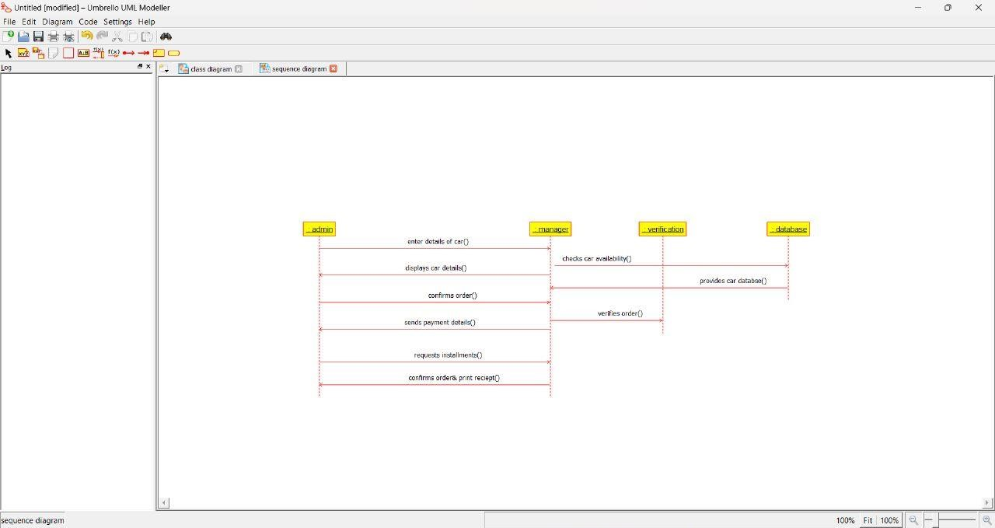

**37.DOCTOR APPOINTMENT SYSTEM USE CASE DIAGRAM:**

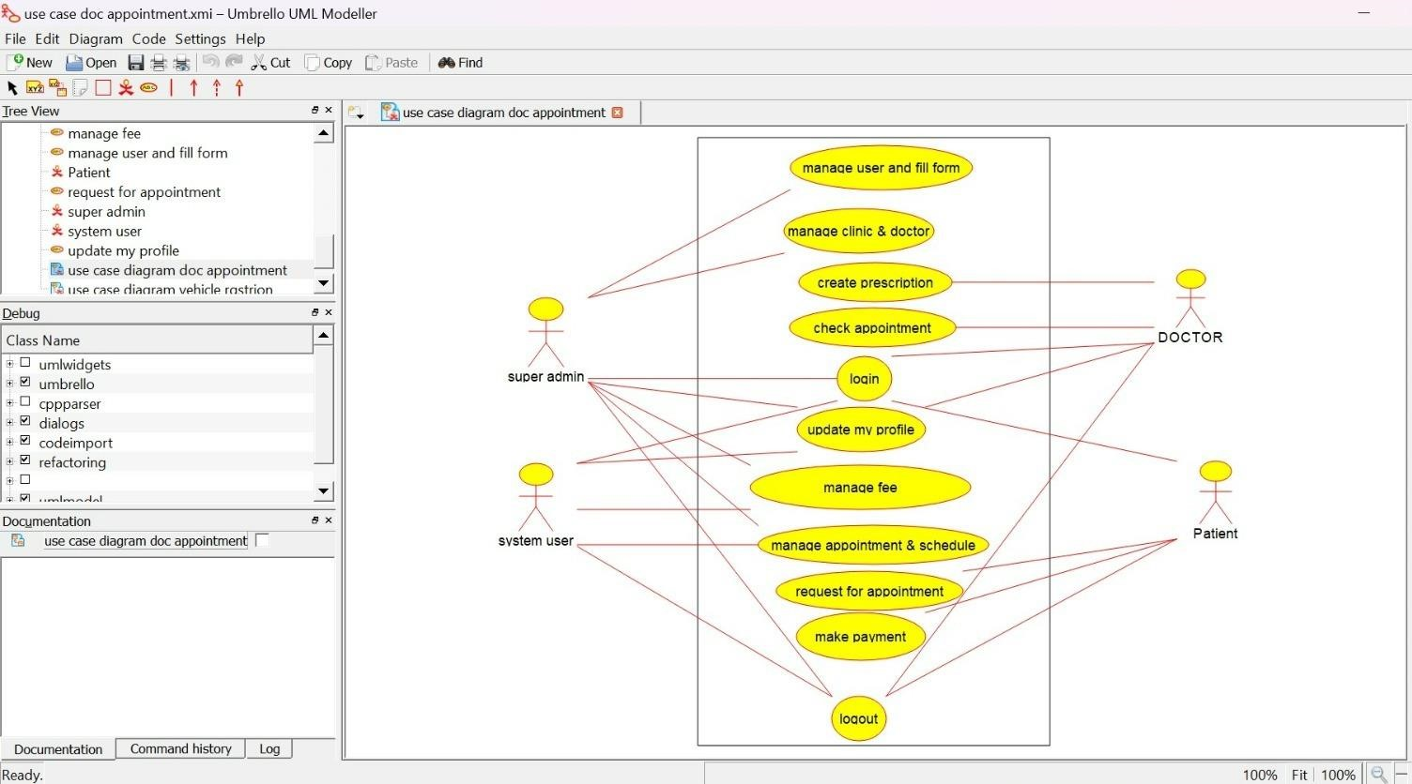

**CLASS DIAGRAM:**

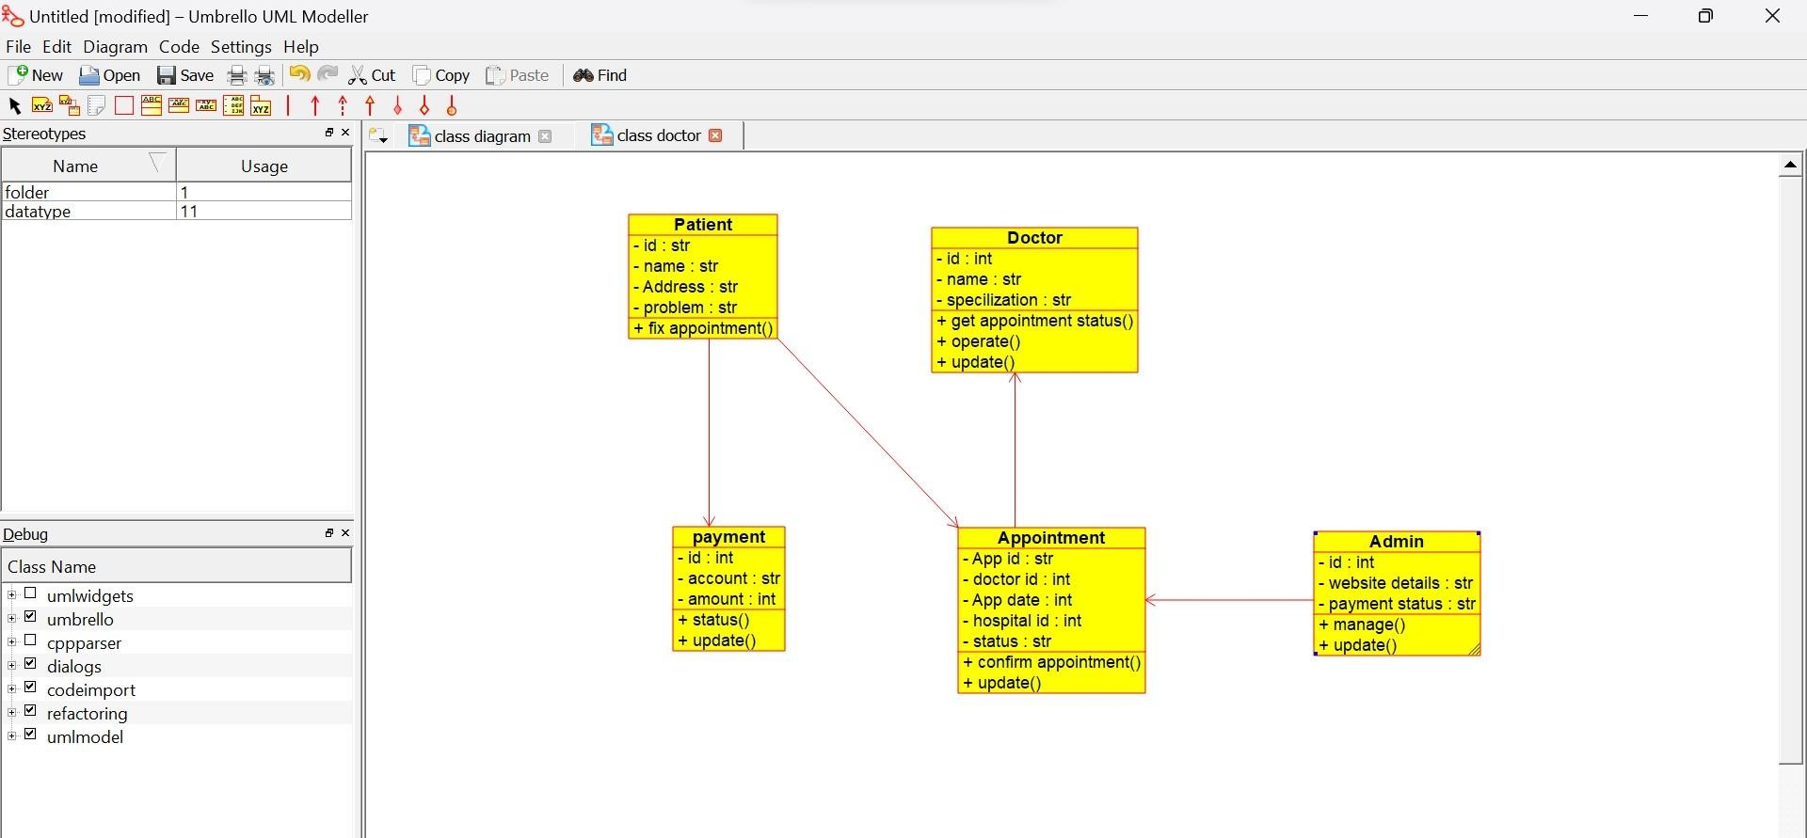

**ACTIVITY DIAGRAM:**

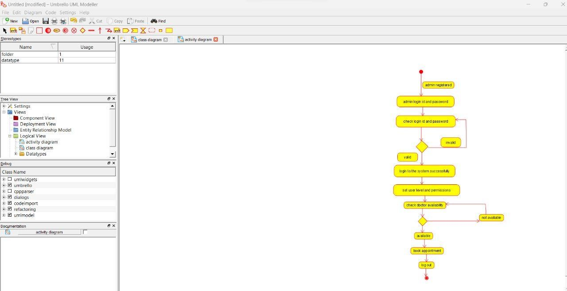

**38.PARLOR RESERVATION SYSTEM USE CASE DIAGRAM:**

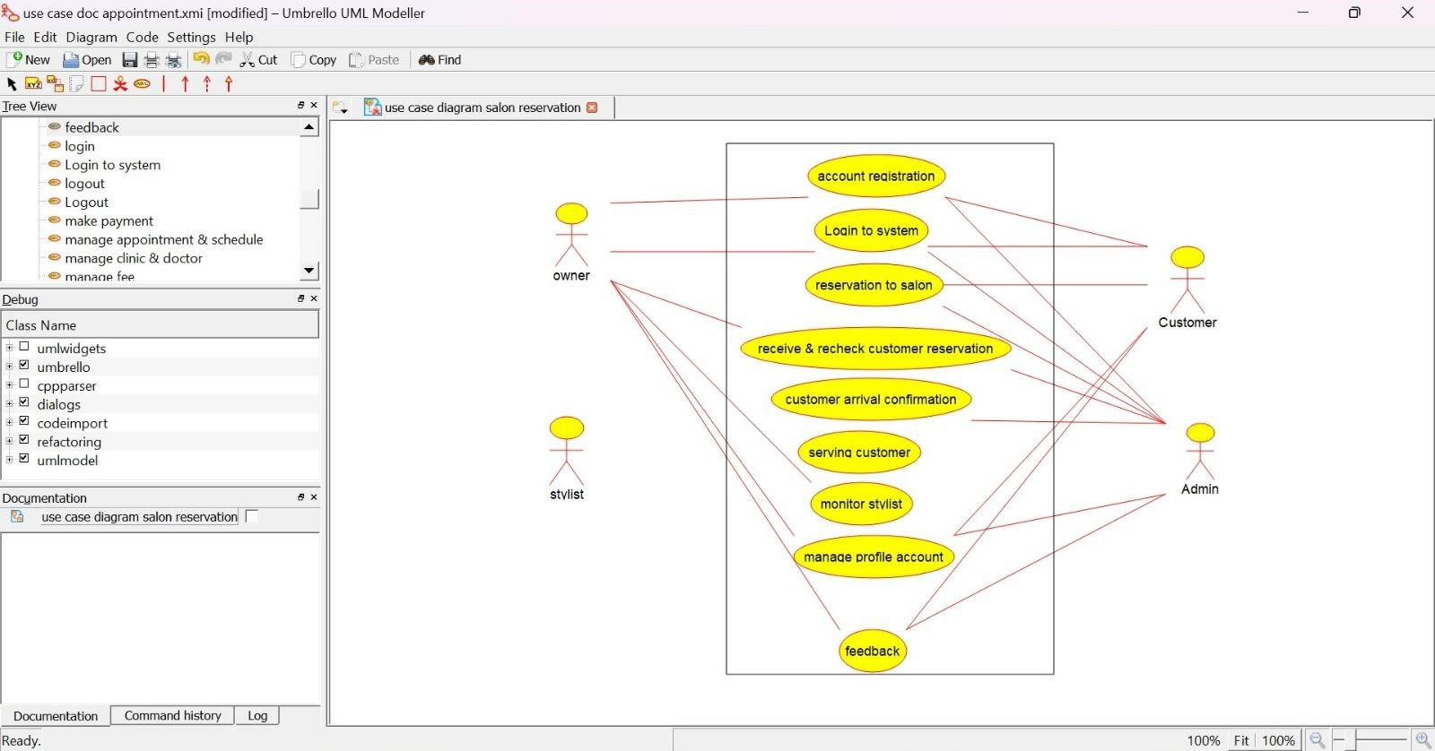

**CLASS DIAGRAM:**

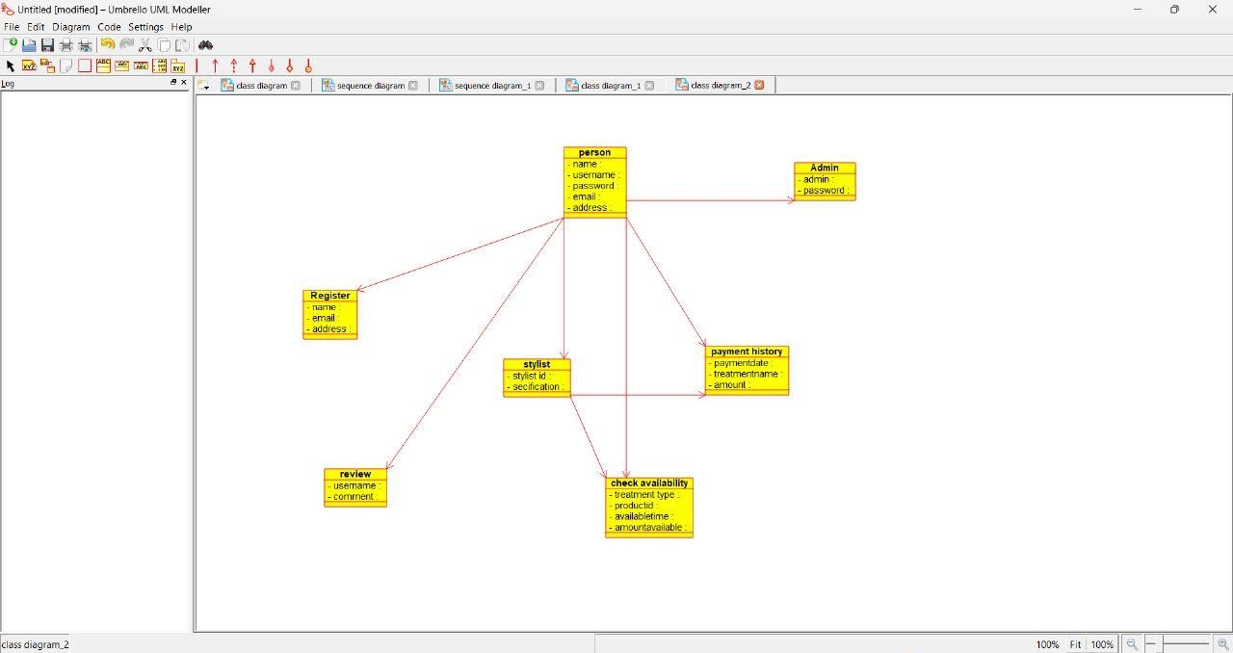

**SEQUENCE DIAGRAM:**

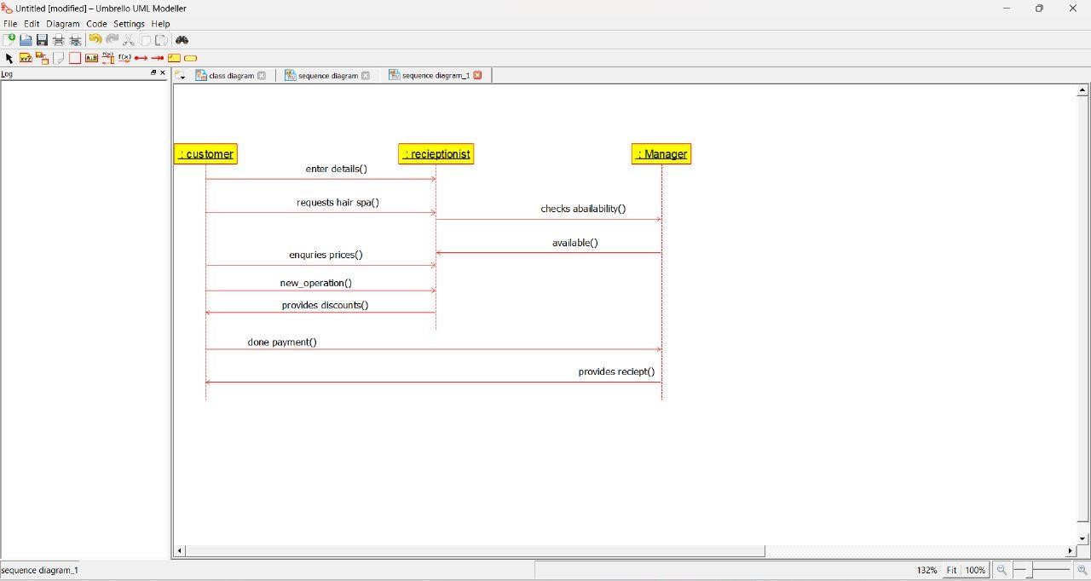

**39.GARDENER BOOKING SYSTEM USE CASE DIAGRAM:**

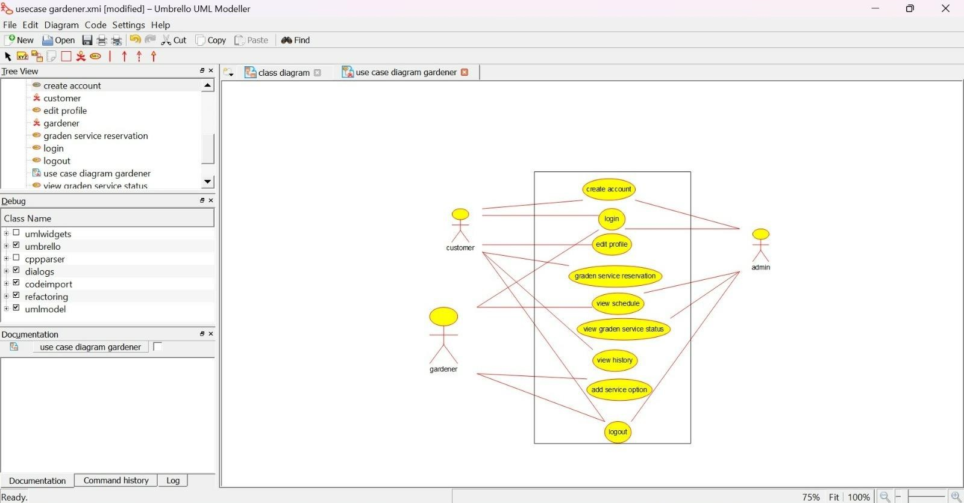

**CLASS DIAGRAM:**

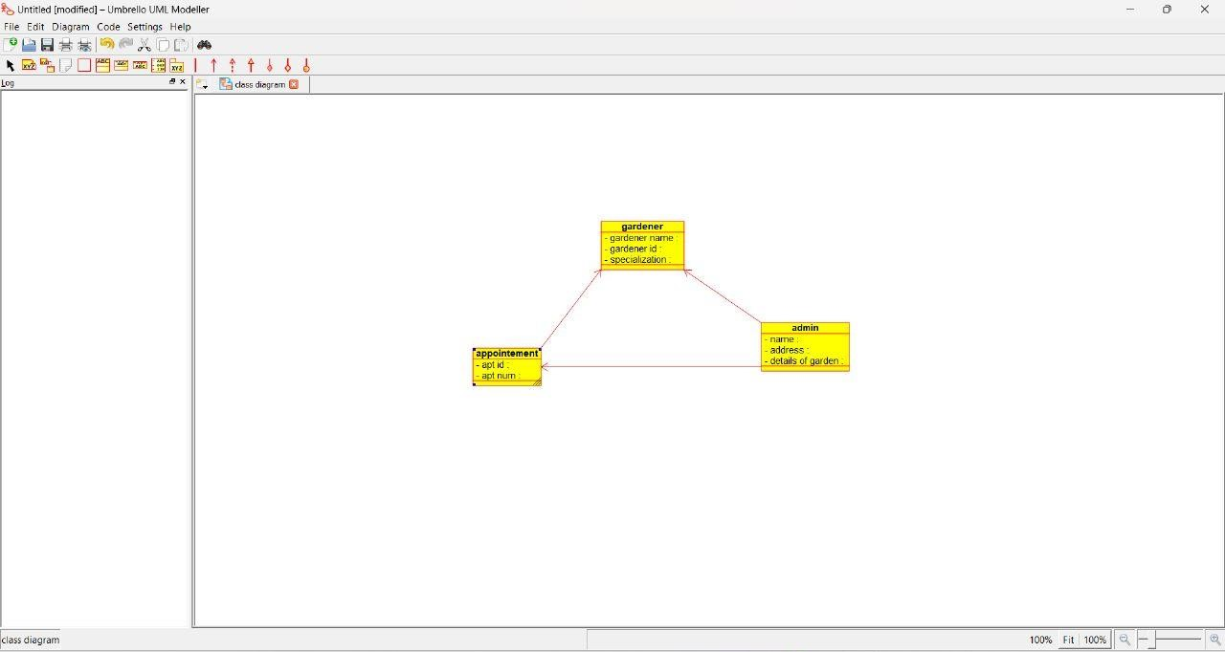

**SEQUENCE DIAGRAM:**

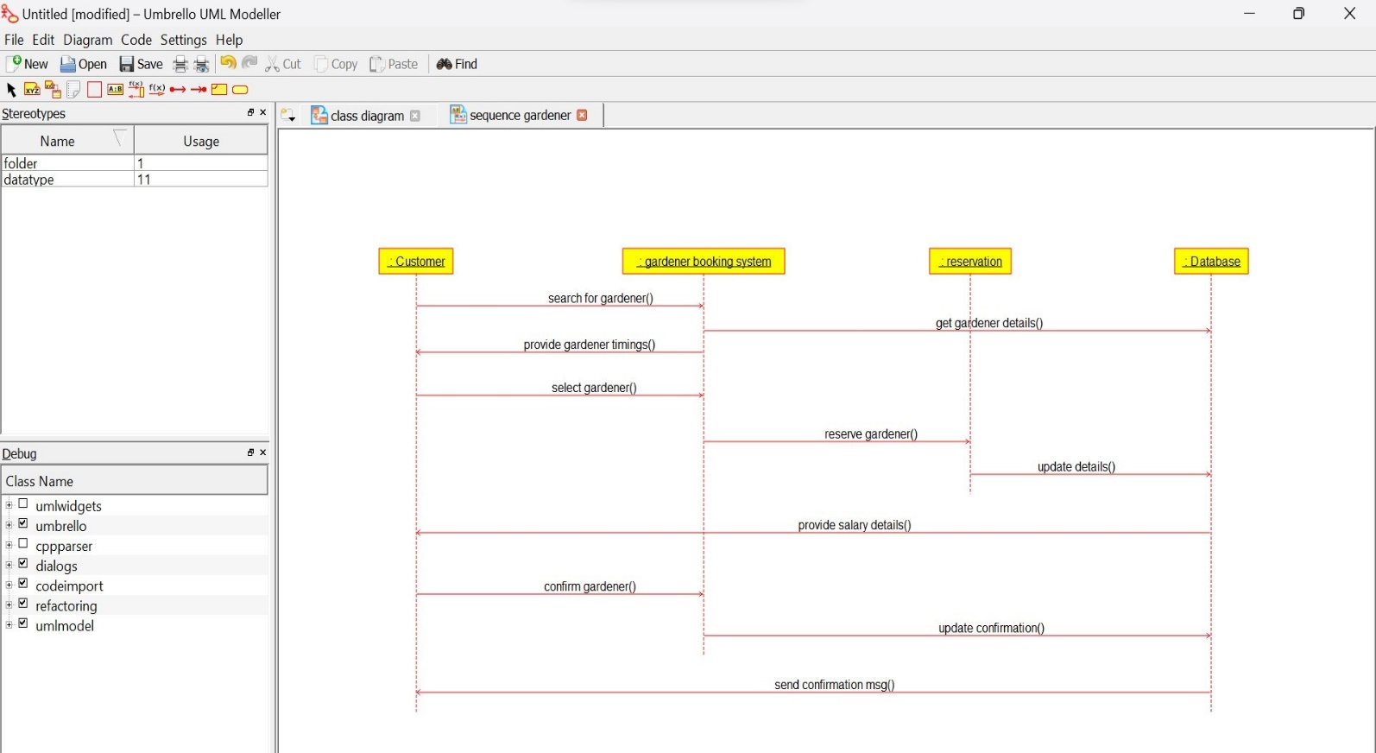

**40.HOME TAX COLLECTION SYSTEM USE CASE DIAGRAM:**

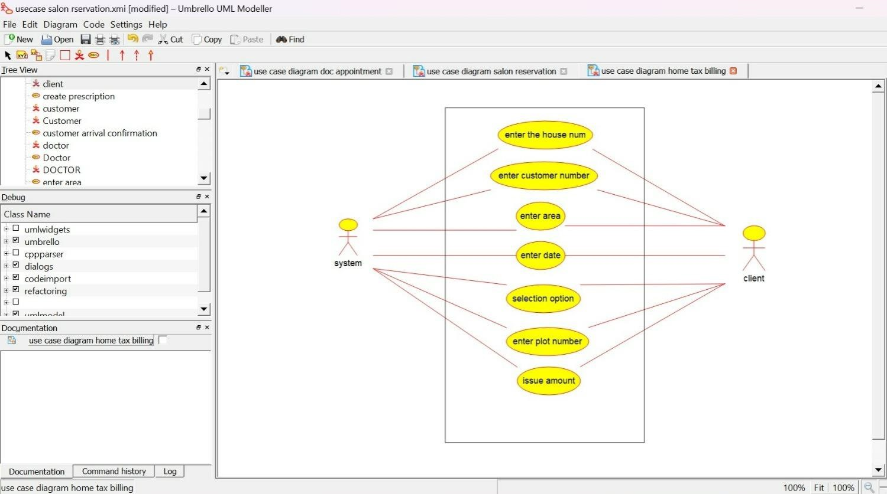

**CLASS DIAGRAM:**

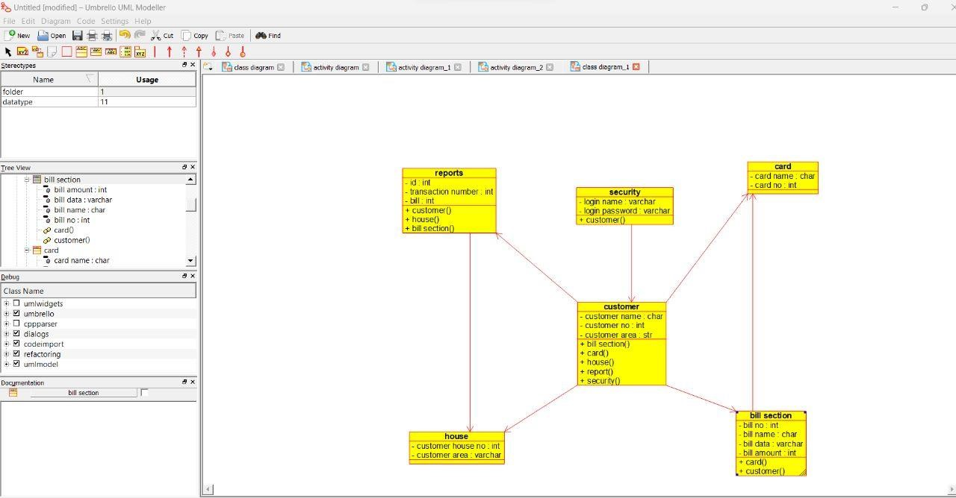

**ACTIVITY DIAGRAM :**

